chr
PROJECT REPORT
Summer Training — Power BI

Project Title | [E-COMMERCE ORDER AND DELIVERY TRACKER]
Student Name | [ISHANT]
Roll Number | [2419253]
Course & Batch | [B.TECH / CSE — 2028]
Department | [CCE]
Institute | [ CGC UNIVERSITY]
Training Period | [08-06-26] to [06-07-26]
Submission Date | [01-07-26]
Guided By | [MS. ASHIMA/ MS. MANDEEP]

1. Declaration

I hereby declare that the project report entitled "[ E-COMMERCE ORDER AND DELIVERY TRACKER]" submitted in partial fulfilment of the Summer Training Programme is an original piece of work carried out by me. The data used in this report has been collected from publicly available sources. The dashboards, visuals shown in this report have been independently created by me in Microsoft Power BI Desktop.

I further confirm that this report or any part of it has not been submitted previously for any academic award.

Signature: _____________ISHANT______________
Name: [ISHANT]
Date: [01/ 07/ 26]

2. Abstract

Write a 150–200 word summary of your project here. Cover the following points in 3–4 sentences each:
- What business problem does your dashboard solve?
- What dataset did you use (source, size, key fields)?
- What Power BI features did you apply (Power Query, DAX, visuals)?
- What insights or outcomes does the final dashboard deliver?

E-Commerce Order and Delivery Tracker
This project presents an interactive E-Commerce Order and Delivery Tracker Dashboard developed using Microsoft Power BI to monitor and analyze online order processing and delivery performance. The dashboard helps businesses track orders from placement to delivery, identify delayed shipments, monitor sales trends, and improve customer satisfaction. It provides a centralized platform for evaluating operational efficiency and supporting data-driven decision-making.
The dataset used for this project is the E-Commerce Order & Delivery Dataset obtained from Chatgpt. The dataset contains thousands of order records with important fields such as Order ID, Customer ID, Product Category, Order Date, Delivery Date, Order Status, Sales Amount, Quantity, Shipping Mode, and Region. These fields enable detailed analysis of both sales and logistics activities.
To build the dashboard, Power Query was used for data cleaning, transformation, and preparation. DAX measures were created to calculate key performance indicators such as Total Orders, Total Revenue, Average Delivery Time, and Delivery Success Rate. Various Power BI visuals including KPI cards, bar charts, line charts, pie charts, maps, and slicers were implemented to create an interactive user experience.
The final dashboard provides valuable insights into order volume, revenue performance, delivery efficiency, and regional trends. It helps stakeholders identify delayed deliveries, evaluate shipping performance, track customer demand patterns, and improve overall business operations through real-time monitoring and analysis.
.]

3. Introduction

3.1 Background

The E-Commerce Order and Delivery Tracker project belongs to the domain of E-Commerce and Supply Chain Analytics. With the rapid growth of online shopping, businesses handle thousands of orders daily and must ensure timely and accurate deliveries to maintain customer satisfaction. Managing order fulfilment , shipping performance, and delivery tracking has become a critical aspect of e-commerce operations.
Data visualization plays an important role in this domain because it transforms large volumes of transactional and delivery data into clear, actionable insights. Visual dashboards help businesses monitor key performance indicators (KPIs) such as total orders, revenue, delivery success rate, average delivery time, and delayed shipments. Instead of analyzing raw data manually, decision-makers can quickly identify trends, patterns, and operational issues.
Organizations use e-commerce dashboards to track business performance in real time and make informed decisions. These dashboards help managers identify delivery bottlenecks, evaluate regional sales performance, monitor customer demand, and optimize logistics operations. By providing a centralized view of both sales and delivery metrics, dashboards improve operational efficiency, enhance customer experience, and support strategic business growth.

3.2 Problem Statement
The E-Commerce Order and Delivery Tracker Dashboard is designed for e-commerce managers, operations managers, logistics teams, and business analysts who need to monitor order processing and delivery performance. Before implementing this dashboard, information related to orders, deliveries, sales performance, and shipment status was often scattered across multiple reports and spreadsheets, making it difficult to obtain a complete view of business operations.
The dashboard solves this problem by providing a centralized and interactive platform that combines sales and delivery data in one place. It enables users to quickly track order volumes, monitor delivery status, identify delayed shipments, and analyze regional performance. With these insights, managers can make faster and more informed decisions regarding inventory planning, logistics optimization, customer service improvements, and overall business performance. This helps increase operational efficiency, reduce delivery delays, and enhance customer satisfaction.

3.3 Objectives
The main objectives of the E-Commerce Order and Delivery Tracker project are:
- Connect to the E-Commerce Order & Delivery dataset and clean, transform, and prepare the data using Power Query.
- Design an efficient data model with appropriate relationships to support accurate reporting and analysis.
- Create meaningful DAX measures such as Total Orders, Total Revenue, Average Delivery Time, Delayed Orders, and Delivery Success Rate.
- Develop an interactive dashboard using multiple visualizations, including KPI cards, bar charts, line charts, pie charts, maps, and slicers.
- Enable cross-filtering and drill-through functionality to allow users to analyze orders and delivery performance in greater detail.
- Monitor key business metrics such as order volume, sales revenue, delivery status, shipping performance, and regional trends.
- Identify delayed deliveries and operational bottlenecks to improve logistics efficiency.
- Analyze customer ordering patterns and product category performance to support business growth.
- Provide real-time insights that help managers make data-driven decisions and improve customer satisfaction.
- Publish the final dashboard to Power BI Service for easy access, sharing, and collaboration among stakeholders.

4. Dataset Description

4.1 Data Source

Download Link | [https://chatgpt.com/share/6a420a08-be90-83ee-a233-9080ff4d4614]
Source Name | CHATGPT (E-Commerce Order & Delivery Dataset)
Dataset Name | [E-Commerce Order & Delivery Dataset]
File Format | [Excel ]
Number of Records | [500 rows]
Number of Columns | [ 34 columns]
Time Period Covered | [JUNE 2026-JULY 2026]

4.2 Key Fields / Columns

Important Columns Used in Analysis
Column Name | Data Type | Description / Role in Analysis
Order ID | Text | Unique identifier for each order; used to track and count total orders.
Order Date | Date | Used to create date hierarchies and perform time-based analysis.
Delivery Date | Date | Used to calculate delivery duration and identify delivery delays.
Customer ID | Text | Unique customer identifier used for customer-level analysis.
Product Category | Text | Product category used in slicers, filters, and category-wise sales analysis.
Sales Amount | Decimal | Revenue generated from each order; used in sales and revenue measures.
Quantity | Whole Number | Number of items ordered; used to analyze product demand.
Region | Text | Geographic region used for regional sales and delivery performance analysis.
Shipping Mode | Text | Delivery method used for shipment; helps evaluate shipping efficiency.
Order Status | Text | Indicates whether an order is Delivered, Pending, Shipped, or Cancelled.
Delivery Status | Text | Used to track successful, delayed, and failed deliveries.
Delivery Time (Days) | Calculated Number | Calculated from Order Date and Delivery Date to measure delivery efficiency.
Payment Method | Text | Used to analyze customer payment preferences and transaction trends.

4.3 Data Quality Issues & Cleaning Steps
The raw E-Commerce Order & Delivery Dataset contained several data quality issues that were resolved using Power Query to ensure accurate analysis and reporting.
- Removed duplicate rows – Duplicate order records were identified using the Remove Duplicates feature and removed to prevent incorrect order counts and revenue calculations.
- Handled missing values – Null values found in columns such as Delivery Status, Shipping Mode, and Region were replaced with "Unknown" or filtered out where appropriate.
- Changed data types – Columns such as Order Date and Delivery Date were originally stored as text and were converted to the Date data type for time-based analysis.
- Created Delivery Time column – A custom column was added to calculate the number of days between Order Date and Delivery Date, enabling delivery performance analysis.
- Standardized text values – Inconsistent values in columns like Order Status and Delivery Status were corrected to maintain data consistency.
- Filtered unnecessary records – Cancelled, incomplete, or test orders were removed to focus on valid business transactions.
- Renamed columns – Column names were standardized and made more user-friendly for easier report development.
- Validated data quality – Checked for incorrect dates, blank records, and invalid values to ensure reliable dashboard results.

5. Data Modelling

5.1 SCHEMA DESIGN
The E-Commerce Order and Delivery Tracker dashboard uses a Star Schema data model to improve query performance, simplify reporting, and support efficient data analysis. The central fact table stores transactional order and delivery data, while dimension tables provide descriptive information used for filtering and analysis.
Component | Description
Schema Type | Star Schema
Fact Table | Orders_Fact – Contains transactional data such as Order ID, Sales Amount, Quantity, Delivery Time, and other measurable business metrics.
Dimension Table 1 | Date_Dim – Contains Date, Day, Month, Quarter, and Year for time-based analysis.
Dimension Table 2 | Product_Dim – Contains Product ID, Product Name, Product Category, and related product details.
Dimension Table 3 | Customer_Dim – Contains Customer ID, Customer Name, and customer-related attributes.
Dimension Table 4 | Region_Dim – Contains Region, State, City, and location information for geographical analysis.
Dimension Table 5 | Shipping_Dim – Contains Shipping Mode, Delivery Status, and logistics-related details.
Relationships | All dimension tables are connected to the Orders_Fact table using their respective key columns. Relationships are One-to-Many (1:M) with Single Filter Direction from dimensions to the fact table.

5.2 Model Diagram
[Insert a screenshot of your Power BI data model view here. Go to Model View in Power BI Desktop → take a screenshot → paste it below.]
[ Screenshot of Data Model — paste here ]
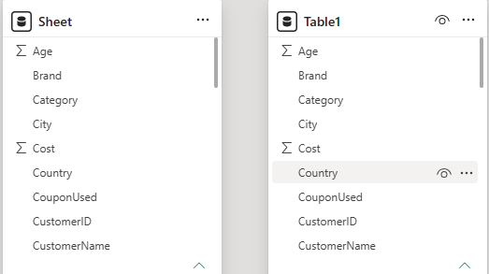
6. Dashboard & Visuals

Describe each page / view in your Power BI report. Include a screenshot of each page.

6.1 Page 1 — Summary / Overview
[Insert screenshot 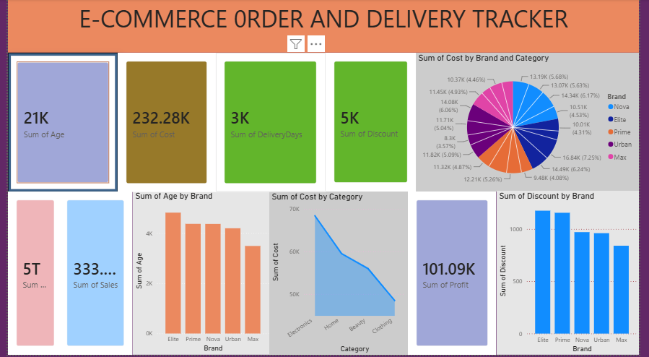of Page 1 here]
[ Screenshot — Overview Page ]

6.1 Dashboard Page – Overview

Visuals Used on this Page
- KPI Cards
  - Total Sales: 333K
  - Total Profit: 101.09K
  - Total Cost: 232.28K
  - Total Discount: 5K
  - Total Delivery Days: 3K
- Pie Chart
  - Cost Distribution by Brand and Category
- Bar Chart
  - Total Age by Brand
- Area/Line Chart
  - Total Cost by Category
- Column Chart
  - Total Discount by Brand
- Slicer
  - Filter options for interactive data exploration

Key Insights from this Page
This dashboard provides an overall view of the E-Commerce Order and Delivery Tracker by displaying key business metrics such as Total Sales, Cost, Profit, Discount, and Delivery Days. The analysis shows that Elite brand contributes the highest value in the Age metric, while the Electronics category generates the highest cost compared to other product categories.
The dashboard also highlights discount distribution across brands and the cost contribution of different categories, helping managers identify high-performing products and brands. These insights support better decision-making related to inventory management, pricing strategies, delivery performance, and overall business operations.

7. Key Findings & Insights

Summarise the top insights your dashboard revealed. Write each insight as a clear, factual statement supported by data. Aim for at least 5 insights.

Finding 1: The dashboard recorded a Total Sales value of approximately 333K, generating a Total Profit of 101.09K, indicating strong overall business performance and profitability.
Finding 2: The Electronics category contributed the highest cost among all product categories, making it the most significant category in terms of business expenditure and sales activity.
Finding 3: Among all brands, Elite recorded the highest value in the Age metric and also showed one of the highest discount contributions, indicating strong customer engagement and promotional activity.
Finding 4: The total discount provided across all orders was approximately 5K, demonstrating the company's use of promotional strategies to attract customers and increase sales volume.
Finding 5: The dashboard shows a cumulative Delivery Days value of 3K, enabling managers to monitor delivery performance and identify opportunities to improve shipping efficiency.
Finding 6: Cost distribution across brands is relatively balanced, but some brands contribute a larger share of overall costs, highlighting areas where cost optimization may improve profitability.
Finding 7: The comparison of discounts by brand reveals that Elite and Prime offer higher discounts than other brands, which may influence customer purchasing decisions and sales performance.
Finding 8: The relationship between Sales (333K), Cost (232.28K), and Profit (101.09K) indicates that the business maintains a healthy profit margin while managing operational and product costs effectively.

8. Learnings & Challenges

8.1 Skills Learned
• Connecting to and importing raw CSV datasets into Power BI.
• Cleaning, transforming, and preparing data using Power Query Editor.
• Handling missing values, duplicate records, and incorrect data types to improve data quality.
• Creating calculated columns such as Delivery Time (Days) for performance analysis.
• Building an efficient Star Schema data model with appropriate one-to-many relationships.
• Writing DAX measures using functions such as SUM, COUNT, CALCULATE, DIVIDE, IF, and FILTER to calculate key business metrics.
• Creating KPIs including Total Sales, Total Cost, Total Profit, Total Discount, and Delivery Performance Metrics.
• Designing interactive dashboards using KPI Cards, Bar Charts, Pie Charts, Line/Area Charts, and Slicers.
• Implementing cross-filtering and interactive visualizations to improve user experience.
• Analyzing sales, delivery efficiency, product categories, and brand performance through data visualization.
• Identifying business trends, operational bottlenecks, and opportunities for improving profitability and customer satisfaction.
• Publishing and sharing Power BI reports for business reporting and decision-making purposes.

8.2 Challenges Faced
- Challenge 1: The dataset contained missing values and inconsistent entries in columns such as Delivery Status, Shipping Mode, and Region. These issues affected the accuracy of the analysis. They were resolved using Power Query by replacing null values with appropriate defaults and removing invalid records.
- Challenge 2: Calculating Delivery Time was challenging because it required finding the difference between Order Date and Delivery Date. A custom column was created in Power Query to accurately calculate delivery duration in days.
- Challenge 3: Some columns were imported with incorrect data types, especially Order Date and Delivery Date, which were stored as text. These columns were converted to the proper Date format to enable time-based analysis and reporting.
- Challenge 4: Creating DAX measures for KPIs such as Total Sales, Total Profit, and Average Delivery Days initially produced incorrect results due to filter context issues. This was resolved by applying appropriate DAX functions and validating calculations against the raw data.
- Challenge 5: Designing a dashboard that displayed both sales and delivery information without cluttering the interface was difficult. The issue was solved by using KPI cards, charts, slicers, and cross-filtering features to create a clean and user-friendly layout.
- Challenge 6: Ensuring data consistency across multiple visuals was challenging. Proper relationships and a structured data model were created to ensure accurate and consistent reporting throughout the dashboard.

9. Conclusion

The E-Commerce Order and Delivery Tracker project successfully addressed the original problem of monitoring and analyzing e-commerce sales and delivery performance through a centralized and interactive Power BI dashboard. By integrating order, sales, cost, profit, discount, and delivery data into a single platform, the dashboard enables users to track key business metrics and make informed decisions efficiently.
The dashboard adds significant value for e-commerce managers, logistics teams, and business analysts by providing real-time insights into sales performance, delivery efficiency, brand performance, and product categories. It eliminates the need for manual reporting and allows users to identify trends, delivery delays, and opportunities for improving profitability and customer satisfaction.
Given additional time, I would enhance the project by incorporating predictive analytics for sales forecasting, advanced delivery performance metrics, and mobile-optimized dashboard layouts. This project strengthened my skills in Power BI, Power Query, DAX, data modeling, and business intelligence, providing valuable practical experience in data-driven decision-making and dashboard development.

10. References

• Microsoft Power BI Documentation
https://learn.microsoft.com/en-us/power-bi/
• Dataset Source (Kaggle)
https://www.kaggle.com/
E-Commerce Order & Delivery Dataset used for sales and delivery analysis.
• DAX Reference Guide
https://dax.guide/
• Power Query M Language Reference
https://learn.microsoft.com/en-us/powerquery-m/
• Microsoft Learn – Power BI Training
https://learn.microsoft.com/en-us/training/powerplatform/power-bi/
• Guy in a Cube (Power BI Tutorials)
https://www.youtube.com/@GuyInACube
• Pragmatic Works Power BI Tutorials
https://www.youtube.com/@PragmaticWorks
• Enterprise DNA – Power BI Learning Resources
https://blog.enterprisedna.co/
• Power BI Community Forum
https://community.powerbi.com/
• Data Visualization and Business Intelligence Resources
https://learn.microsoft.com/en-us/power-bi/guidance/
END OF REPORT

